**SECTION A-46 MARKS**

**Attempt** all **questions in this section.**

1. **Complete the following equations. (@01 mark)**
2. ${}_{13}^{27}{Al}$**+ ${}_{0}^{1}n$**  **β + ………………………………..…..**
3. **4 ${}_{1}^{1}H$ ${}_{2}^{4}{He}$**   **+ ……………………………..………**
4.   ${}_{92}^{239}U$ ${}_{91}^{239}U$**+ ……………………………..………**
5. **An element, X has two naturally occurring isotopes with isotopic masses and relative abundances as shown below.**

|  |  |
| --- | --- |
| **Isotopic mass** | **Relative atomic mass** |
| **79** | **50.5** |
| **81** | **49.5** |

1. **State what is meant by the term relative atomic mass. (01 mark)**

**……………………………………………………………………………………………………………………………………………………………………………………………………………………………………………………………………………………………………………………………………………………………………………………………………………………………………………...............**

1. **Calculate the average atomic mass of element, X. (02 marks)**

**……………………………………………………………………………………………………………………………………………………………………………………………………………………………………………………………………………………………………………………………………………………………………………………………………………………………………………………………………………………………………………………………………………………………………………………………**

1. **Write equation for the reaction between hot concentrated aqueous sodium hydroxide solution and: (@01½ marks)**
2. **Aluminium oxide.**

**……………………………………………………………………………………………………………………………………………………………………………………………………………………………………………..**

1. **Beryllium oxide.**

**……………………………………………………………………………………………………………………………………………………………………………………………………………………………………………..**

1. **Lead (IV) oxide.**

**……………………………………………………………………………………………………………………………………………………………………………………………………………………………………………..**

1. **An organic compound, R has the structure of:**



1. **Name the functional groups present in organic compound, R. (02 marks)**

**……………………………………………………………………………………………………………………………………………………………………………………………………………………………………**

1. **Write equation for the reaction between organic compound, R and : (@01 mark)**
2. **Bromine in tetrachloromethane.**

**……………………………………………………………………………………………………………………………………………………………………………………………………………………………………**

1. **Saturated sodium hydrogensulphite solution.**

**……………………………………………………………………………………………………………………………………………………………………………………………………………………………………**

1. **State what would be observed in (b) (i). (01 mark)**

**……………………………………………………………………………………………………………………………………………………………………………………………………………………………………………..**

1. **Define the term heat of formation. (01 mark)**
2. **The enthalpies for formation of some selected compounds are shown in the table below.**

|  |  |  |  |
| --- | --- | --- | --- |
| **Compounds** | **H2O** | **CO** | **C8H18** |
| **Enthalpy of formation (kJ/mol)** | **-242** | **-111** | **-169** |

**Calculate the enthalpy change for the following reaction.**

**8CO(g)+ 17H2(g)** **C8H18(g)+ 8H2O(g) (03 marks)**

**……………………………………………………………………………………………………………………………………………………………………………………………………………………………………………………………………………………………………………………………………………………………………………………………………………………………………………………………………………………………………………………………………………………………………………………………………………………………………………………………………………………………………………………………………………………………………………………………………………………………………………………………………………………………………………………………………………………**

1. **Complete the following reaction equations and write the IUPAC names of the main organic product in each case. (@01½ marks)**
2. **C6H5Br + CH3I**  **………………………………………………**

**Name of product: …………………………………………………………………………………..**

1. **CH3CH=CH2**  **……………………………………………..**

**Name of product: ………………………………………………………………………………….**

1. **HCOOH + CH3CH2CH2OH** **…………………………………………….**

**Name of product: ………………………………………………………………………………….**

1. 

**Name of product: ………………………………………………………………………………….**

1. **Compound, Q is a green solid which dissolves in water to give a pale green solution. The solution of compound, Q formed a red precipitate with butanedionedioxime solution and a reddish brown solution when a few drops of iron (II) chloride solution were added to it. When compound, Q was heated with concentrated sulphuric acid, methanoic acid was formed.**
2. **Identify compound, Q. (01 mark)**

**……………………………………………………………………………………………………………………………………………………………………………………………………………………………………**

1. **Write equation for the reaction that took place when compound, Q was heated with concentrated sulphuric acid. (01½ marks)**

**……………………………………………………………………………………………………………………………………………………………………………………………………………………………………………..**

1. **Write equation (s) for the reaction (s) that take place when excess ammonia solution is added to a solution of compound, Q. (02½ marks)**

**……………………………………………………………………………………………………………………………………………………………………………………………………………………………………………………………………………………………………………………………………………………………………………………………………………………………………………………………………………………………………………………………………………………………………………………………………………………………………………………………………………………………………………………………………………………………………………………………………………………………………………………………………………………………………………………………………………………………………………………………………………………………………………………………………………………………………………………**

1. **20.0cm3 of hydrocarbon, Z [CxHy] was exploded with 200.0cm3 of oxygen gas. On cooling to room temperature, the residual gases occupied 160.0cm3. When the residual gases were passed via aqueous sodium hydroxide solution, the volume reduced to 20.0cm3.**
2. **(i). Write equation for the reaction between hydrocarbon, Z and oxygen gas. (01 mark)**

**…………………………………………………………………………………………………………………………………………………………………………………………………………………………………………….**

1. **Determine the molecular formula of compound, Z. (2½ marks)**

**…………………………………………………………………………………………………………………………………………………………………………………………………………………………………………………………………………………………………………………………………………………………………………………………………………………………………………………………………………………………………………………………………………………………………………………………………………………………………………………………………………………………………………………………………………………………………………………………………………………………………………………………………………………………………………………………………………………………………………………………………………………………………………………………………………………………………………………….**

1. **Compound, Z burns with a sooty flame. When compound, Z was treated with hot alkaline potassium managanate (VII) solution followed by dilute hydrochloric acid, Compound, T was formed. Compound, T reacts with magnesium ribbon liberating hydrogen gas.**
2. **Identify compounds, Z & T. (01 mark)**

**………………………………………………………………………………………………………………………………………………………………………………………………………………………………**

1. **Write equation to show how hydrocarbon, Z can be obtained from an alkyne. (01½ marks)**

**……………………………………………………………………………………………………………………………………………………………………………………………………………………………………………………………………………………………………………………………………………………………………………………………………………………………………………………………………………………………………………………………………………………………………………………………………………………………………………………………………………………………………………………………………………………………………………………………………………………………………………………………………………………………………………………………………………………………………………………………………………………………………………….**

1. **State what is meant by the term an ideal solution. (01 mark)**

**…………………………………………………………………………………………………………………………………………………………………………………………………………………………………………………………………………………………………………………………………………………………………………………………………………………………………………………………………………………………………………………………………………………………………………………………………………………….**

1. **The vapour pressure of water and methanol are 3.173kPa & 16.785kPa respectively at 293K. Assuming the mixture of the two liquids behaves as an ideal solution and that it contains 0.88 mole fraction of water. Calculate the:**
2. **Vapour pressure of the mixture. (02½ marks)**

**……………………………………………………………………………………………………………………………………………………………………………………………………………………………………………………………………………………………………………………………………………………………………………………………………………………………………………………………………………………………………………………………………………………………………………………………………………………………………………………………………………………………………………………………………………………………………………………………………………………………………………………………………………………………………………………………………………………………………………………………………………………………………………….**

1. **Percentage of methanol in the vapour. (01 mark)**

**……………………………………………………………………………………………………………………………………………………………………………………………………………………………………………………………………………………………………………………………………………………………………………………………………………………………………………………………………………………………………………………………………………………………………………………………………………………………………………………………………………………………………………………………………………………………………………………………………………………………………………………………………………………………………………………………………………………………………………………………………………………………………………….**

1. **During the manufacture of sulphuric acid by contact process, sulphur dioxide gas is catalytically oxidized to sulphur trioxide gas according to the equation below: 2SO2(g) + O2(g)** **2SO3(g) ∆Hϴ = -197kJ/mol. The sulphur trioxide formed is then absorbed in 98% sulphuric acid to form compound, T.**
2. **State the industrial conditions used to obtain maximum yield of sulphur trioxide gas. (01½ marks)**

**…………………………………………………………………………………………………………………………………………………………………………………………………………………………………………………………………………………………………………………………………………………………………………………………………………………………………………………………………………………………………………………………………………………………………………………………………………………….**

1. **Write equation to show compound, T can be converted in to sulphuric acid. (01 mark)**

**…………………………………………………………………………………………………………………………………………………………………………………………………………………………………………….**

1. **Write equation for the reaction between hot concentrated sulphuric acid and: (@01 mark)**

**…………………………………………………………………………………………………………………………………………………………………………………………………………………………………………….**

1. **State what would be observed in (c) (i). (0½ mark)**

**…………………………………………………………………………………………………………………………………………………………………………………………………………………………………………….**

**SECTION B-54 MARKS**

**Attempt** ANy **six questions in this section.**

1. **State what would be observed and write equation for the reaction that would take place when:**
2. **A mixture of acidified potassium manganate (VII) and sodium ethanedioate is heated. (02½ marks)**

**Equation:**

**…………………………………………………………………………………………………………………………………………………………………………………………………………………………………………………………………………………………………………………………………………………………………………………………………………………………………………………………………………………………….**

**Observations:**

**………………………………………………………………………………………………………………………………………………………………………………………………………………………………………………………………………………………………………………………………………………………………………………………………………………………………………………………………………………………………**

1. **Acidified potassium chromate (VI) solution is added to hydrogen peroxide. (02½ marks)**

**Equation:**

**…………………………………………………………………………………………………………………………………………………………………………………………………………………………………………………………………………………………………………………………………………………………………………………………………………………………………………………………………………………………….**

**Observations:**

**………………………………………………………………………………………………………………………………………………………………………………………………………………………………………………………………………………………………………………………………………………………………………………………………………………………………………………………………………………………………**

1. **3.4 drops of bromine water is added to phenylamine. (02 marks)**

**Equation:**

**…………………………………………………………………………………………………………………………………………………………………………………………………………………………………………………………………………………………………………………………………………………………………………………………………………………………………………………………………………………………….**

**Observations:**

**………………………………………………………………………………………………………………………………………………………………………………………………………………………………………………………………………………………………………………………………………………………………………………………………………………………………………………………………………………………………**

1. **Benzoic acid is added to a saturated solution of sodium hydrogencarbonate. (02 marks)**

**Equation:**

**…………………………………………………………………………………………………………………………………………………………………………………………………………………………………………………………………………………………………………………………………………………………………………………………………………………………………………………………………………………………….**

**Observations:**

**………………………………………………………………………………………………………………………………………………………………………………………………………………………………………………………………………………………………………………………………………………………………………………………………………………………………………………………………………………………………**

1. **State what is meant by the term freezing point constant of a substance. (01 mark)**

**………………………………………………………………………………………………………………………………………………………………………………………………………………………………………………………………………………………………………………………………………………………………………………………………………………………………………………………………………………………………………………………………………………………………………………………………………………………………………………..**

1. **The table below shows the freezing point of various concentrations of a non-volatile solute D in water at a pressure of 760mmHg.**

|  |  |  |  |  |  |  |
| --- | --- | --- | --- | --- | --- | --- |
| **Concentration of non-volatile solute D[g/dm3]** | **0** | **30** | **60** | **90** | **120** | **150** |
| **Freezing point/[ᵒC]** | **0** | **-0.16** | **-0.32** | **-0.49** | **-0.65** | **-0.81** |

**Plot a graph of freezing point depression against concentration of non-volatile solute D. (04 marks)**

1. **Determine the:**
2. **Slop of the graph you have drawn in (b). (01½ marks)**

**……………………………………………………………………………………………………………………………………………………………………………………………………………………………………………………………………………………………………………………………………………………………………………………………………………………………………………………………………………………………………………………………………………………………………………..**

1. **Relative molecular mass of non-volatile solute D. (02½ marks)**

**……………………………………………………………………………………………………………………………………………………………………………………………………………………………………………………………………………………………………………………………………………………………………………………………………………………………………………………………………………………………………………………………………………………………………………………………………………………………………………………………………………………………………………………………………………………………………………………………………………………………………………………………………………………………………………………………………………………………………………………………………………………………………………….**

1. **Write a mechanism for the reaction that occurs between a mixture of:**
2. **Ethanol and concentrated sulphuric acid at 140ᵒC. (02½ marks)**

**………………………………………………………………………………………………………………………………………………………………………………………………………………………………………………………………………………………………………………………………………………………………………………………………………………………………………………………………………………………………………………………………………………………………………………………………………………………………………………………………………………………………………………………………………………………………………………………………………………………………………………………………………**

1. **Boiling methylbenzene and chlorine gas in the presence of ultra-violet light. (03 marks)**

**………………………………………………………………………………………………………………………………………………………………………………………………………………………………………………………………………………………………………………………………………………………………………………………………………………………………………………………………………………………………………………………………………………………………………………………………………………………………………………………………………………………………………………………………………………………………………………………………………………………………………………………………………………………………………………………………………………………………………………………………………………………………………………………………………**

1. **Propanal and phenylhydrazine. (03½ marks)**

**…………………………………………………………………………………………………………………………………………………………………………………………………………………………………………………………………………………………………………………………………………………………………………………………………………………………………………………………………………………………………………………………………………………………………………………………………………………………………………………………………………………………………………………………………………………………………………………………………………………………………………………………………………………………………………………………………………………………………………………………………………………………………………………………………….**

1. **Write equations to show how each of chlorine and iodine react with: (@01½ marks)**
2. **Sodium iodide solution.**
3. **Chlorine gas.**

**……………………………………………………………………………………………………………………………………………………………………………………………………………………………………**

1. **Iodine.**

**……………………………………………………………………………………………………………………………………………………………………………………………………………………………………**

1. **Sodium thiosulphate solution.**
2. **Chlorine gas.**

**……………………………………………………………………………………………………………………………………………………………………………………………………………………………………**

1. **Iodine.**

**……………………………………………………………………………………………………………………………………………………………………………………………………………………………………**

1. **Hot concentrated potassium hydroxide solution.**
2. **Chlorine gas.**

**……………………………………………………………………………………………………………………………………………………………………………………………………………………………………**

1. **Iodine.**

**……………………………………………………………………………………………………………………………………………………………………………………………………………………………………**

1. **State the two methods by which the solubility of a sparingly soluble salt may be determined. (01 mark)**

**………………………………………………………………………………………………………………………………………………………………………………………………………………………………………………………..**

1. **Copper (II) iodate is sparingly soluble in water.**

**Write:**

1. **An equation for the solubility of copper (II) iodate. (01 mark)**

**……………………………………………………………………………………………………………………………………………………………………………………………………………………………………**

1. **An expression for solubility product, Ksp of copper (II) iodate. (0½ mark)**

**…………………………………………………………………………………………………………………………………………………………………………………………………………………………….**

1. **The solubility product of copper (II) iodate at room temperature is 1.4 x 10-7 mol-3/dm9. Calculate the solubility in grams per litre at the same temperature of copper (II) iodate in: (@02½ marks)**
2. **Water.**

**………………………………………………………………………………………………………………………………………………………………………………………………………………………………………………………………………………………………………………………………………………………………………………………………………………………………………………………………………………………………………………………………………………………………………………………………………………………………………………………………………………………………………………………………………………………………………………………………………………………………………………………………………………………………………………………………**

1. **0.1M potassium iodate.**

**………………………………………………………………………………………………………………………………………………………………………………………………………………………………………………………………………………………………………………………………………………………………………………………………………………………………………………………………………………………………………………………………………………………………………………………………………………………………………………………………………………………………………………………………………………………………………………………………………………………………………………………………………………………………………………………………**

1. **Comment on your answer in (c) above. (01½ marks)**

**…………………………………………………………………………………………………………………………………………………………………………………………………………………………………………………………………………………………………………………………………………………………………………………………………………………………………………………………………………………..**

1. **Write equation (s) to show how the following compounds can be synthesized. Indicate the condition (s) for the reaction (s).**
2.  **From ethene (02 marks)**

**………………………………………………………………………………………………………………………………………………………………………………………………………………………………………………………………………………………………………………………………………………………………………………………………………………………………………………………………………………………………………………………………………………………………………………………………………………………………………………………………………………………………………………**

1. **Benzene From phenylmethanol (02½ marks)**

**………………………………………………………………………………………………………………………………………………………………………………………………………………………………………………………………………………………………………………………………………………………………………………………………………………………………………………………………………………………………………………………………………………………………………………………………………………………………………………………………………………………………………………………………………………………………………………………………………………………………………………………………………………………………………………………………………………….**

1. **Cyclohexanol From ethyne (04½ marks)**

**…………………………………………………………………………………………………………………………………………………………………………………………………………………………………………………………………………………………………………………………………………………………………………………………………………………………………………………………………………………………………………………………………………………………………………………………………………………………………………………………………………………………………………………………………………………………………………………………………………………………………………………………………………………………………………………………………………………**

1. **State how the following anhydrous chlorides can be prepared. (@01 mark)**
2. **Tin (II) chloride.**

**………………………………………………………………………………………………………………………………………………………………………………………………………………………………**

1. **Tin (IV chloride.**

**………………………………………………………………………………………………………………………………………………………………………………………………………………………………**

1. **State why tin (IV) chloride is formed but tin (II) bromide is not. (02 marks)**

**………………………………………………………………………………………………………………………………………………………………………………………………………………………………………………………………………………………………………………………………………………………………………………………………………………………………………………………………………………….**

1. **Write equation for the reaction between water and chloride in (a): (@01 mark)**
2. **Tin (II) chloride.**

**………………………………………………………………………………………………………………………………………………………………………………………………………………………………**

1. **Tin (IV) chloride.**

**………………………………………………………………………………………………………………………………………………………………………………………………………………………………**

1. **State what would be observed and write equation for the reaction that would take place when tin (II) chloride is added to acidified aqueous solution of sodium dichromate (VII).**

**Observation (s)**

**………………………………………………………………………………………………………………………………………………………………………………………………………………………………………..**

**Equation:**

**………………………………………………………………………………………………………………………………………………………………………………………………………………………………………..**

1. **Give a reason for your answer in (d) above. (0½ mark)**

**………………………………………………………………………………………………………………………………………………………………………………………………………………………………………..**

1. **Rubber is a natural polymer whose monomer is 2-methylbuta-1,3-diene.Write the structure of:**
2. **Monomer of rubber. (0½ mark)**

**……………………………………………………………………………………………………………………………………………………………………………………………………………………………………**

1. **Structural formula of rubber. (01 mark)**

**……………………………………………………………………………………………………………………………………………………………………………………………………………………………………**

1. **Name the type of polymerization involved in the formation of rubber. (0½ mark)**

**…………………………………………………………………………………………………………………**

1. **State how:**
2. **Vulcanization of natural rubber is carried out. (01 mark)**

**……………………………………………………………………………………………………………………………………………………………………………………………………………………………………**

1. **Vulcanization improves the properties of natural rubber. (03 marks)**

**…………………………………………………………………………………………………………………………………………………………………………………………………………………………………………………………………………………………………………………………………………………………………………………………………………………………………………………………………………………………………………………………………………………………………………………………..**

1. **The structural formula of a polymer, R is:**



**The osmotic pressure of a solution containing 5.5g/dm3 of polymer, R in benzene is 106.39Pa at 20ᵒC.**

1. **Calculate the relative molecular mass of polymer, R. (02 marks)**

**………………………………………………………………………………………………………………………………………………………………………………………………………………………………………………………………………………………………………………………………………………………………………………………………………………………………………………………………………………………………………………………………………………………………………………………………………………………………………………………………………………………………**

1. **Determine the number of monomers that formed the polymer, R. (01 mark)**

**…………………………………………………………………………………………………………………………………………………………………………………………………………………………………………………………………………………………………………………………………………………………………………………………………………………………………………………………………………………………………………………………………………………………………………….**

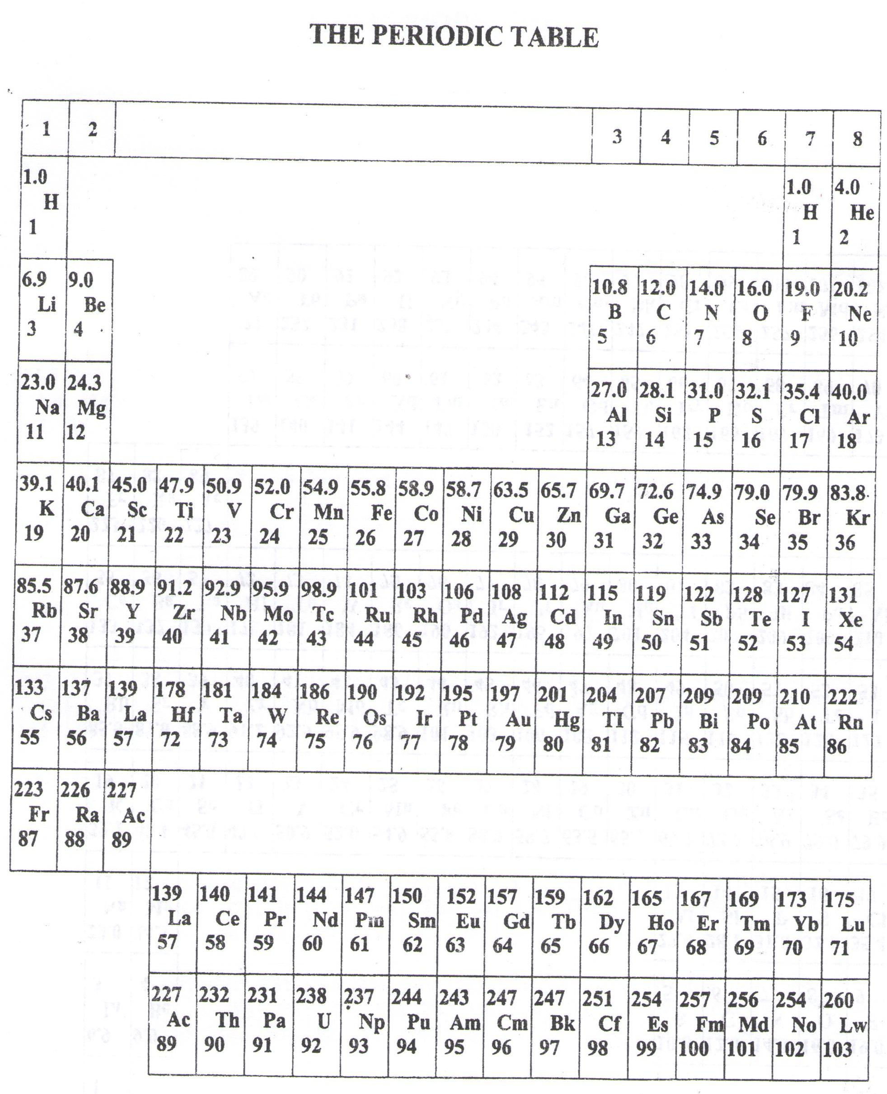

* ===END===

WELCOME TO SENIOR SIX, YEAR 2023

This is the last page of the printed paper, Page 21